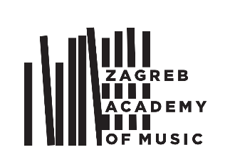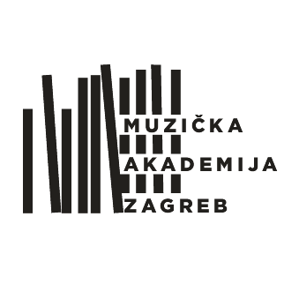

**UNIVERSITY OF ZAGREB ACADEMY OF MUSIC**

ZAGREB, Trg Republike Hrvatske 12

www.muza.unizg.hr

**Application form**

|  |
| --- |
| **Lifelong learning - Artistic training program** |
| **In the academic year ___________** |

(Complete the application electronically or fill in with uppercase letters)

|  |  |  |  |
| --- | --- | --- | --- |
| **I. General information** | | | |
| Name and surname |  | | |
| Father’s/mother’s first name |  | ID number |  |
| Date of birth |  | City and state/country of birth |  |
| Permanent address |  | Citizenship |  |
| Phone number |  | Cell phone number |  |
| e-mail address |  | | |
| **II. Application** | | | |
| I am applying for | ☐composition - electronic music  ☐voice/singing  ☐conducting/choir conducting  ☐solo instrument with accompaniment  ☐solo instrument without accompaniment  ☐orchestral music | | (specify which instrument/course) |
|  |
|  |
|  |
|  |
|  |
| Mentor | |  | |
| Piano accompanist at the audition | |  | |
| Documents needed with the application | 1. Biography with detailed information about concert/performance experience 2. Original or certified copy of current diploma (Bachelor of music or or equivalent) 3. Official transcripts of records (undergraduate and graduate courses) 4. Copy of passport 5. For instrumental audition – list of works prepared for the audition 6. For composition – Complete scores of several works (with audio/video recording) 7. Audition fee – 500 HRK - Proof of payment | | |
| Additional information |  | | |
| **Along with all the required documents, please provide up to date information about your education:** | | | |

|  |  |  |
| --- | --- | --- |
| **III. Current education** | | |
| **A) Information about completed music studies (undergraduate):** | | |
| University/Higher learning institution |  | |
| City, Country |  | |
| Major field of study |  | |
| Mentor |  | |
| Grade point average |  | |
| **B) Information about graduate studies (if any):** | | |
| University/Higher learning institution |  | |
| City, Country |  | |
| Major field of study |  | |
| Mentor |  | |
| Grade point average |  | |
| **C) Additional education:** | | |
|  | | |
| **IV. Additional information** | | |
| Candidates who acquired their diploma at a University abroad must complete the academic qualification procedure. Candidates are required to send all their documents to:  Muzička akademija, Trg Republike Hrvatske 12, 10000 Zagreb  E mail: : [referada@muza.hr](mailto:referada@muza.hr)  fax:+385 1 4872 380  Additional information can be obtained at the Academy of Music Student Office: Trg Republike Hrvatske 12, tel. +385 1 4826 808 or by e mail: [referada@muza.hr](mailto:referada@muza.hr)  Payment information:  MUZIČKA AKADEMIJA SVEUČILIŠTA U ZAGREBU, TRG REPUBLIKE HRVATSKE 12, 10000 ZAGREB, HRVATSKA  BANK: PRIVREDNA BANKA ZAGREB, Račkoga 6 | SWIFT CODE (BIC): PBZGHR2X | IBAN: HR50 2340 0091 1001 5916 7 (kn)  In case of money wire transfer – please include your ID or passport number as well as your permanent address. | | |
| Date and place | | Signature |