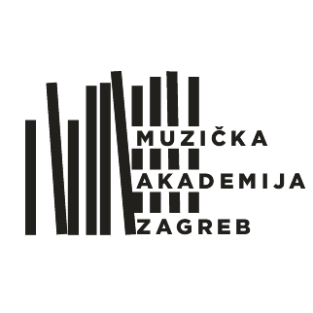
SVEUČILIŠTE U ZAGREBU – MUZIČKA AKADEMIJA
ZAGREB, Trg Republike Hrvatske 12
www.muza.unizg.hr

Application form
Artistic training – lifelong learning program
In the academic year ___________
(Complete the application electronically or fill in with uppercase letters)
I. General information
Name and surname
Father’s/mother’s first name |  | ID number
Date of birth |  | City and state/country of birth
Permanent address |  | Citizenship
Phone number |  | Cell phone number
e-mail address
II. Application
I am applying for | ☐composition - electronic music  ☐voice/singing  ☐conducting/choir conducting  ☐solo instrument with accompaniment  ☐solo instrument without accompaniment  ☐orchestral music |  | (specify which instrument/course)
Mentor
Piano accompanist at the audition
Documents needed with the application | - Biography with detailed information about concert/performance experience  - Original or certified copy of current diploma (Bachelor of music or or equivalent)  - Official transcripts of records (undergraduate and graduate courses)  - Copy of passport  - For instrumental audition – list of works prepared for the audition  - For composition – Complete scores of several works (with audio/video recording)  - Audition fee – 66,00 euro - Proof of payment
Additional information
Along with all the required documents, please provide up to date information about your education:

III. Current education
A) Information about completed music studies (undergraduate):
University/Higher learning institution
City, Country
Major field of study
Mentor
Grade point average
B) Information about graduate studies (if any):
University/Higher learning institution
City, Country
Major field of study
Mentor
Grade point average
C) Additional education:
IV. Additional information
Candidates who acquired their diploma at a University abroad must complete the academic qualification procedure. Candidates are required to send all their documents to:

Muzička akademija, Trg Republike Hrvatske 12, 10000 Zagreb
E mail: : referada@muza.hr
fax:+385 1 4872 380
Additional information can be obtained at the Academy of Music Student Office: Trg Republike Hrvatske 12, tel. +385 1 4826 808 or by e mail: referada@muza.hr

Payment information:
MUZIČKA AKADEMIJA SVEUČILIŠTA U ZAGREBU, TRG REPUBLIKE HRVATSKE 12, 10000 ZAGREB, HRVATSKA
BANK: PRIVREDNA BANKA ZAGREB, Račkoga 6 | SWIFT CODE (BIC): PBZGHR2X | IBAN: HR50 2340 0091 1001 5916 7 (kn)

In case of money wire transfer – please include your ID or passport number as well as your permanent address.
Date and place |  | Signature

