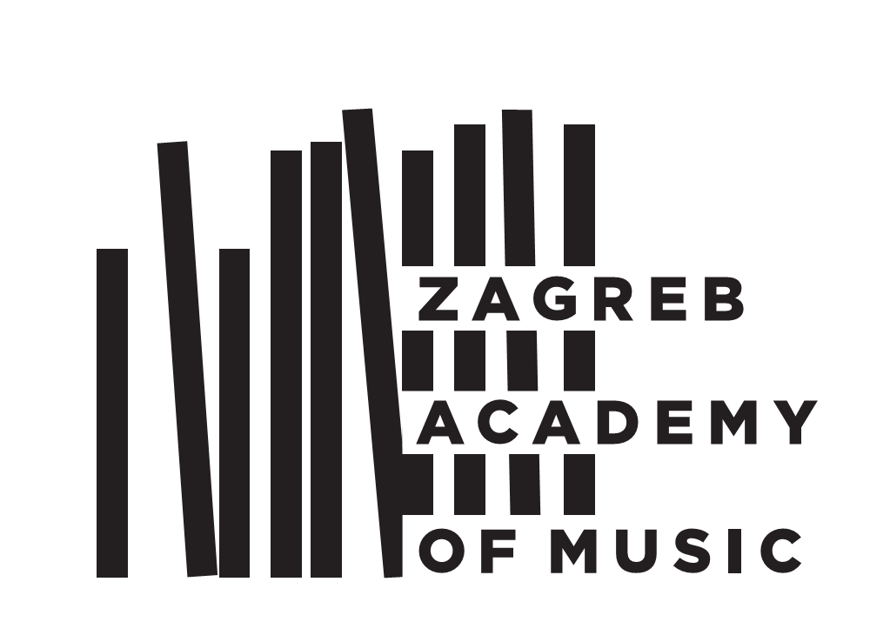
THE UNIVERSITY OF ZAGREB
THE ACADEMY OF MUSIC
Trg Republike Hrvatske 12,
HR-10000 Zagreb, Croatia
www.muza.unizg.hr
A P P L I C A T I O N
for admission exam for the ___ year of study
in ____________ academic year

A. General Information
Applicant’s first name and last name
Parent's first name and last name ____________________________________
Day/month/year of birth
City and country of birth Citizenship
Home address (permanent address)
Tel.: Mobile: E-mail:
Address for correspondence (if different from above)

Tel.: Mobile: E-mail:

B. General Education
Secondary School
School
City State Duration in years

C. Musical Education
Private Musical Studies
School / subject
City State Duration in years
Musical Secondary School
School / subject
City State Duration in years

D. The applicant is applying for the following:
Major
Professor (optional)

Date Signature

Please enclose the following attachments:
- A short biography with a description of musical and general education (in English, from 100 to 200 words)
- Copy of birth certificate
- School reports for general and musical education
- Payment certificate for 300,00 kn into Academy bank account for exam expenses IBAN: HR50 2340 0091 1001 5916 7 (BANK: PRIVREDNA BANKA ZAGREB, Račkoga 6, Zagreb, Croatia)

This application form together with the required attachments should be received by the Student Office of the Academy. Candidates will be informed about further procedures.

Mailing address: Muzička akademija, Trg Republike Hrvatske 12, 10000 Zagreb, Croatia
Head of the Student Office: Mrs. Renata Kovačić
Tel.: ++385 1 4810 200 (106)
Fax: ++385 1 4872 380
E-mail: rkovacic@muza.hr

